## yatay çizgi



Pharmacy Management System

**Database System / CENG 301  
  
  
  
Presented by**Ata Berk Sarı / 220444050  
Saip Deniz İnal / 210444087  
Ziya Üre / 210444050

**Problem Definition**  
  
In a traditional pharmacy setting, relying on manual logs or fragmented spreadsheets creates critical risks such as life-threatening inventory shortages, the accidental sale of expired medications, and the inability to quickly access a patient’s medical history during an emergency. But the SQL-based Pharmacy Management System solves these problems by centralizing data into a secure, relational environment where stock levels are tracked in real-time, expiration alerts are automated, and complex relationships between patients, prescriptions, and suppliers are managed with absolute data integrity. By replacing human error with structured queries, the system transforms a chaotic, paper-based workflow into a streamlined operation that ensures both regulatory compliance and, most importantly, patient safety.

**ER Diagrams**  
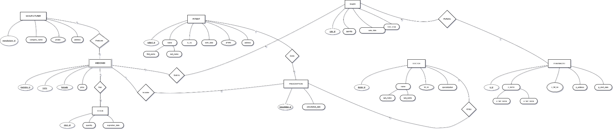  
  
  
  
  
  
  
  
  
  
  
  
  
  
  
  
  
  
  
  
  
  
  
  
  
  
  
  
  
  
  
  
**Mapping of ER Diagrams**  
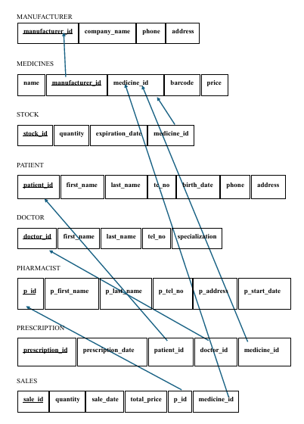

**Table Descriptions**

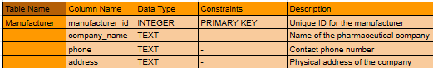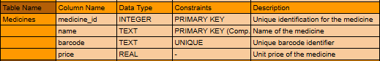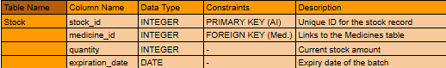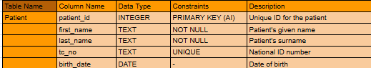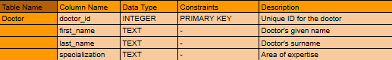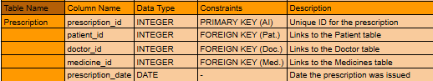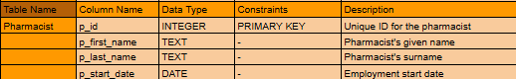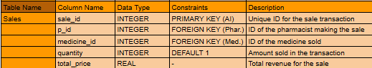 **Screen Shots of UI Design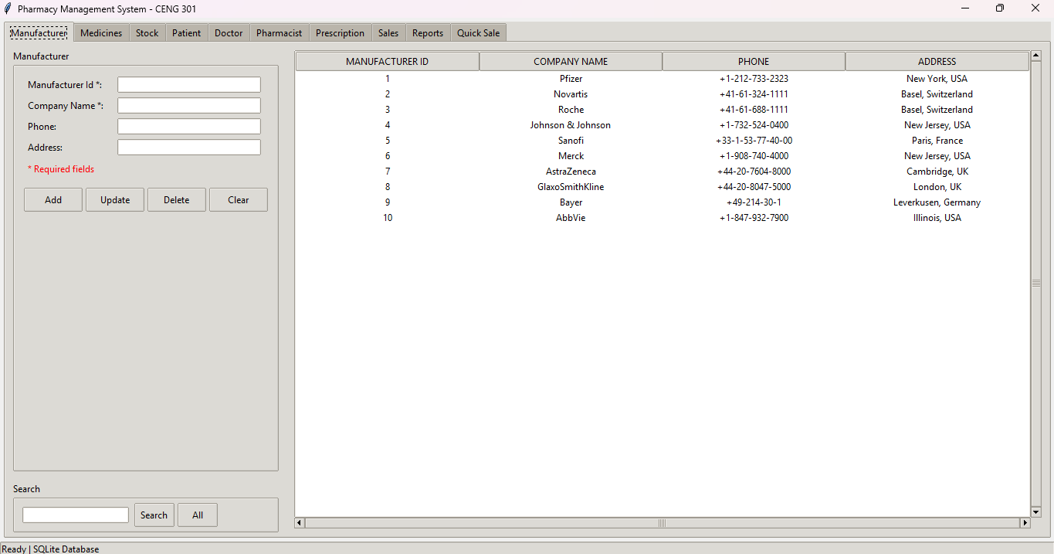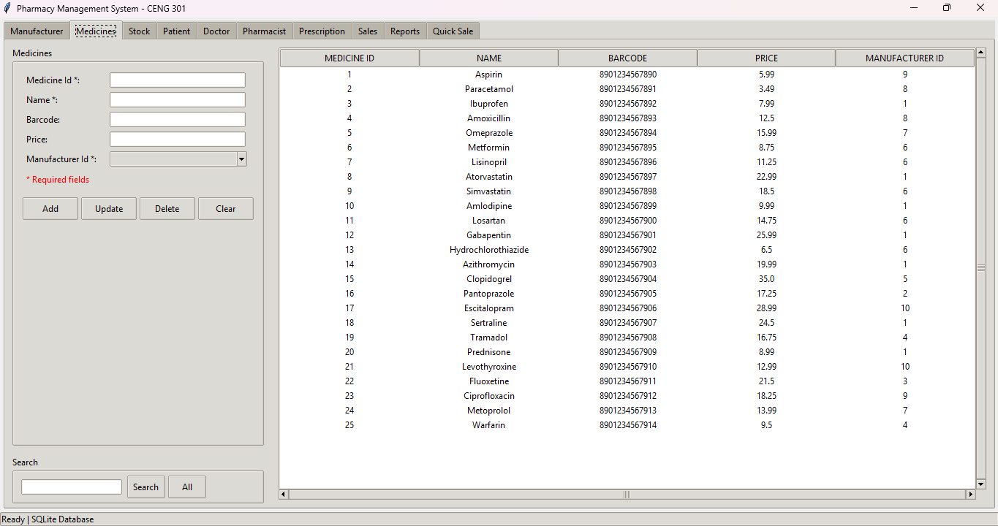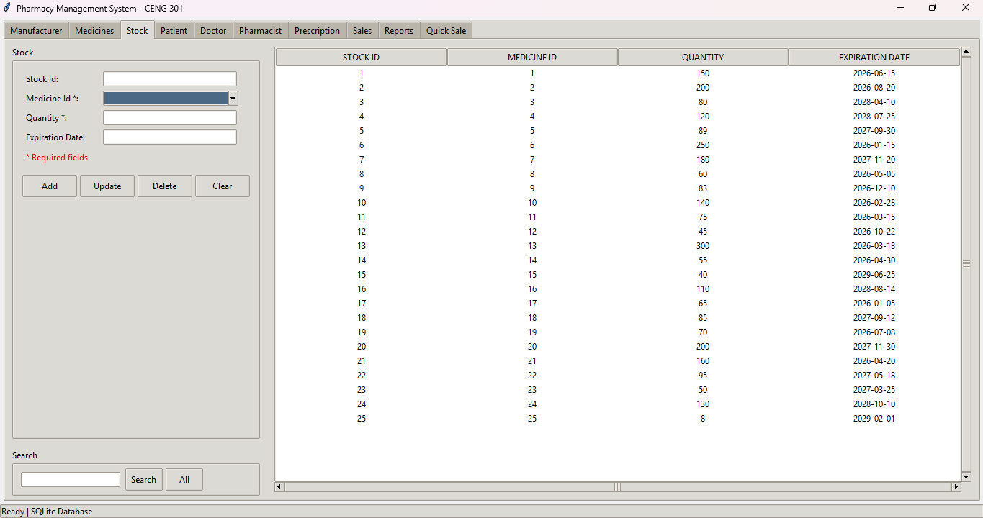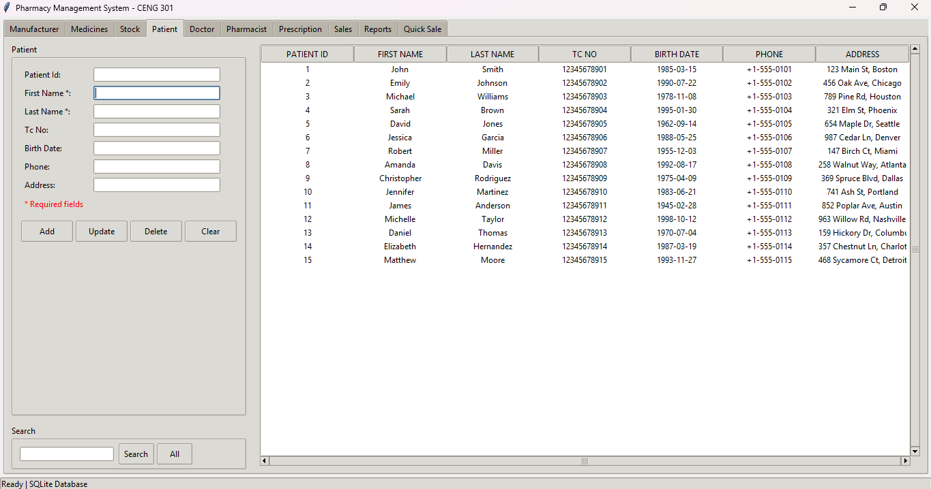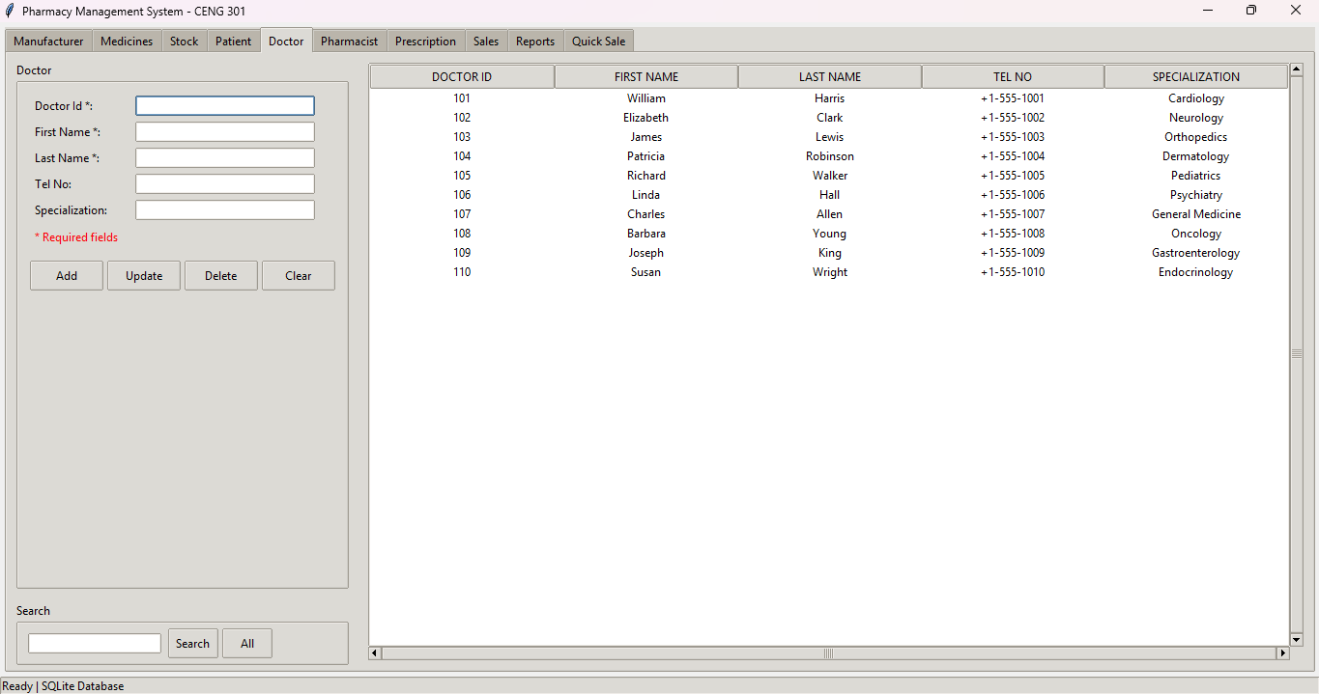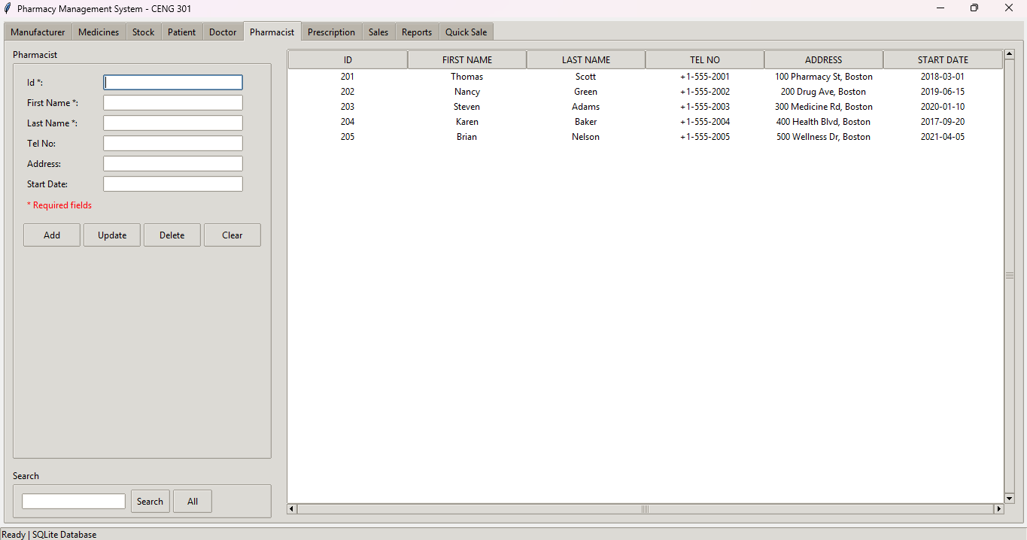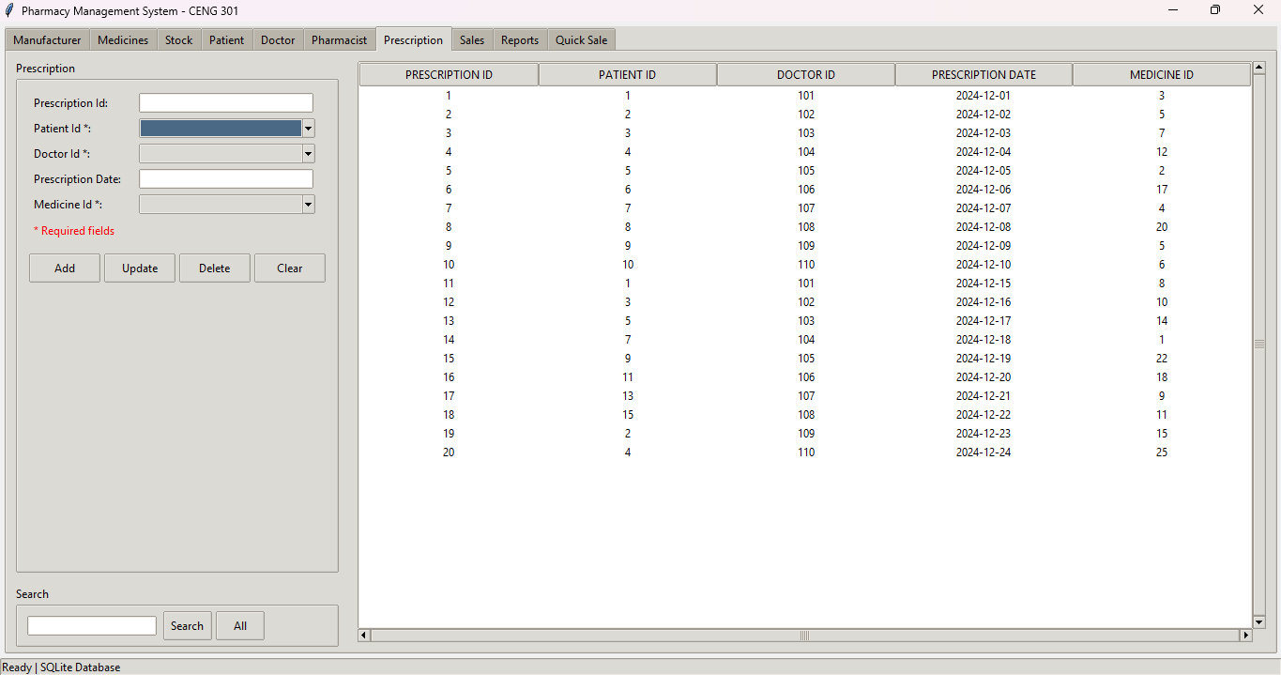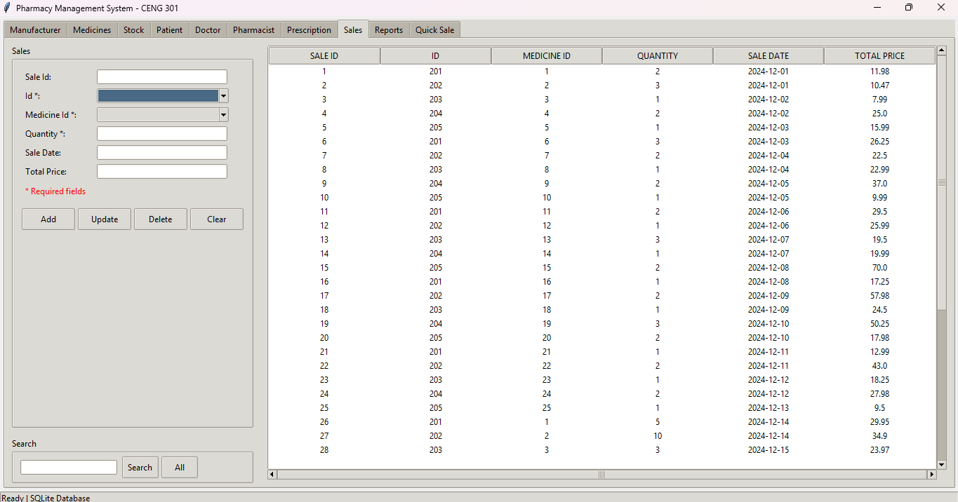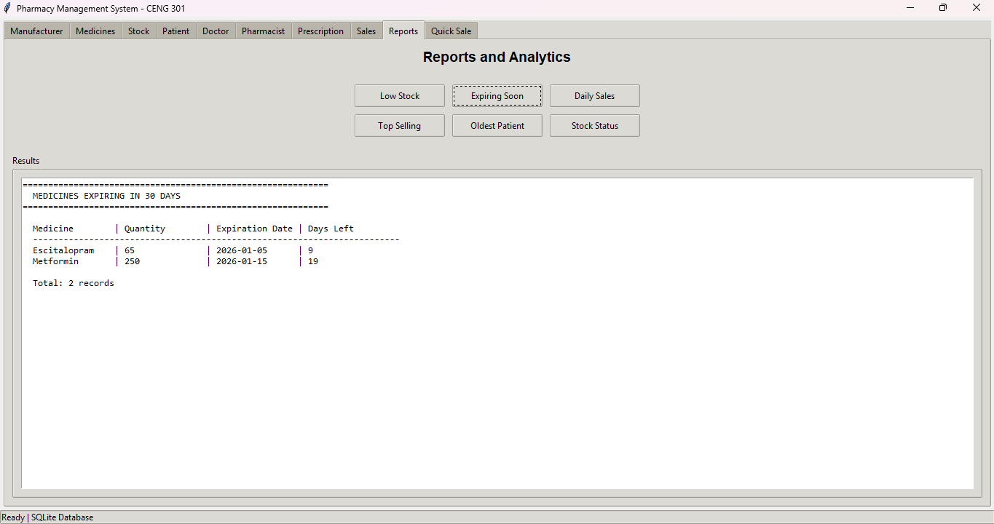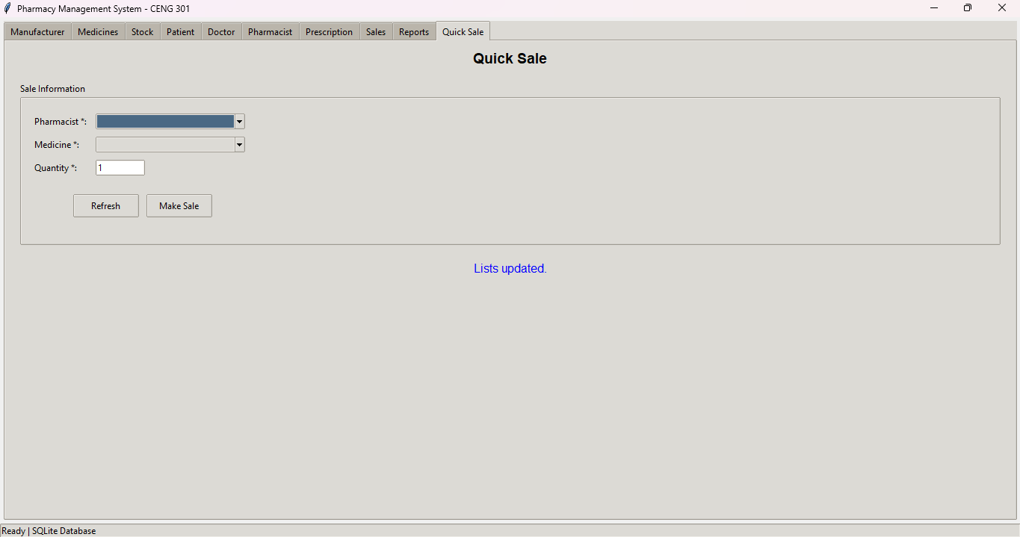 Description of Functionalities**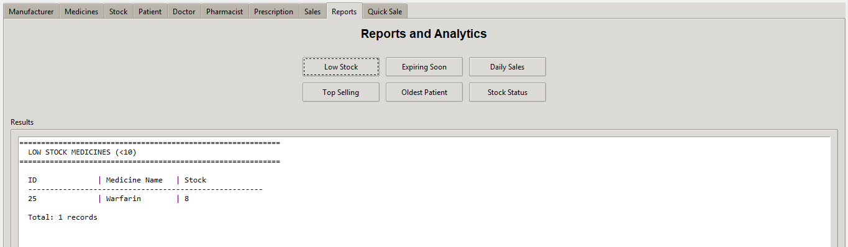  
Low Stock: This feature is like an early warning system. It automatically lists medicines that are almost sold outso the pharmacist knows exactly what they need to order next.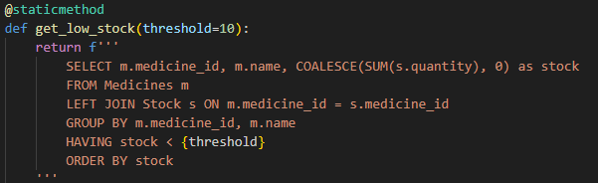  
  
Expiring Soon: To keep patients safe, this tool tracks the "best before" dates of every batch. It highlights any medicine that is going to expire within the next month, showing a countdown of how many days are left until it’s no longer safe to sell.  
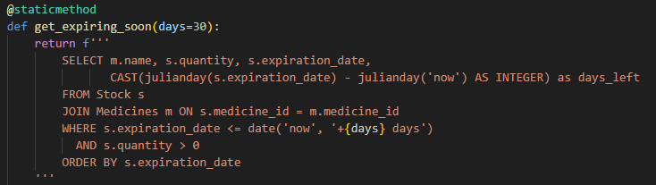  
  
  
  
  
  
 Daily Sales: This gives the pharmacist a quick look at how the business is doing. It looks back at the last 30 days and calculates how many sales were made each day and the total amount of money earned.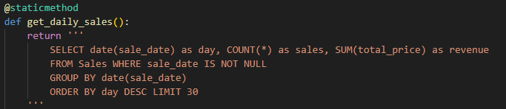  
  
Top Selling: This part of the system identifies which medicines people are buying the most. It ranks the products by popularity and total profit, which helps the pharmacist decide which items are worth keeping more of in stock.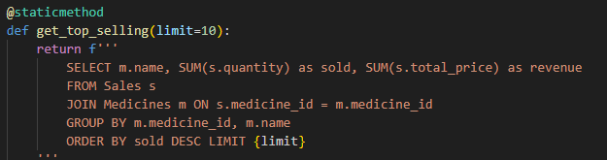  
  
Oldest Patient: This feature can find the oldest patient in the records. It automatically calculates their age based on their birthday and shows their details, which is a great way to show how the system handles complex date calculations.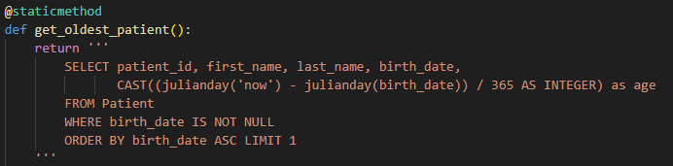  
  
  
  
  
  
  
Stock Status: This is the main dashboard where the pharmacist can see everything at once. It pulls data from different parts of the system to show the medicine name, who made it, and exactly how many are left on the shelf.